1) Question: <https://leetcode.com/problems/kids-with-the-greatest-number-of-candies/description/>

Solution Link:- <https://leetcode.com/problems/kids-with-the-greatest-number-of-candies/submissions/1481001659>

Time Complexity: O(n)

Space Complexity: O(n)

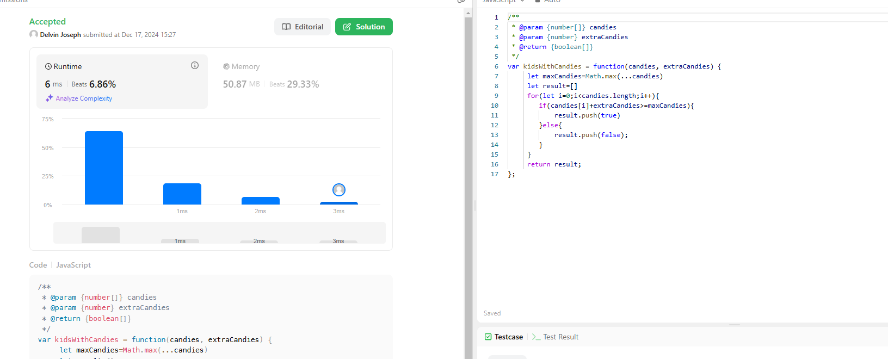Screenshot:

Description:

Time complexity:O(n)

Iterates all over the n sized array and there is only one loop and pushs the element to the result array

Space complexity: O(n)

The result array keep on change with respect to the size of the array

2) Question: <https://leetcode.com/problems/count-number-of-pairs-with-absolute-difference-k/description/>

Solution Link: <https://leetcode.com/problems/count-number-of-pairs-with-absolute-difference-k/submissions/1483452160>

Time Complexity: O(n)

Space Complexity: O(n)

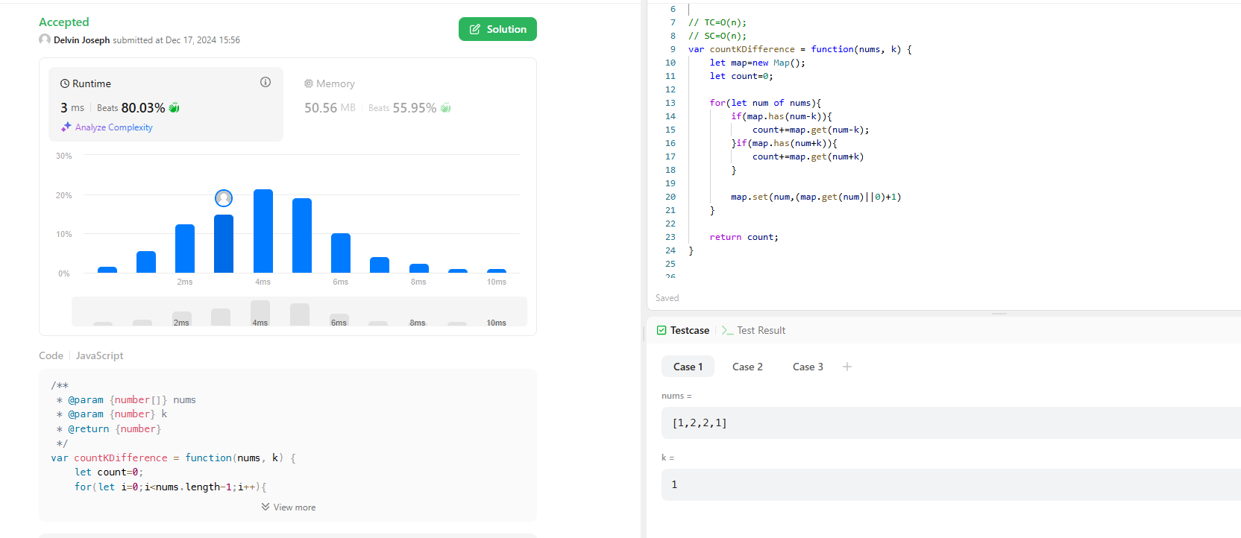Screenshot:

Description:

Time complexity:O(n)

Iterates all over the n sized array and there is only one loop

Space complexity: O(n)

Because of using the HashMap Data structure extra space is taking the space can be different but the worst case is O(n)

3)Question: <https://leetcode.com/problems/find-common-elements-between-two-arrays/description/>

Solution: <https://leetcode.com/problems/find-common-elements-between-two-arrays/submissions/1483455684>

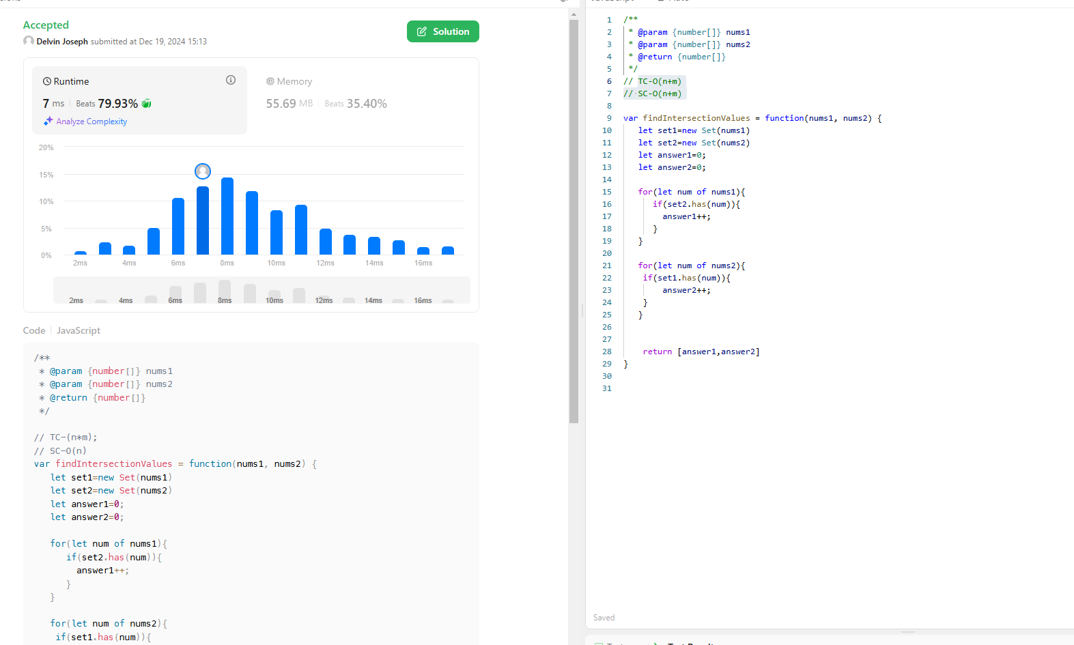Screenshot:

Time Complexity: O(n+m)

Space Complexity: O(n+m)

Description:

Time Complexity: O(n+m)

It iterates 2 different array with size of n and m there for the time takes to finish the loop is n+m

Space Complexity: O(n+m)

It takes 2 extra space which is set 1 and set 2 so it takes extra space with n+m complexity

4)Question: <https://leetcode.com/problems/number-of-good-pairs/description/>

Solution: <https://leetcode.com/problems/number-of-good-pairs/submissions/1482725397>

Time Complexity: O(n)

Space Complexity: O(n)

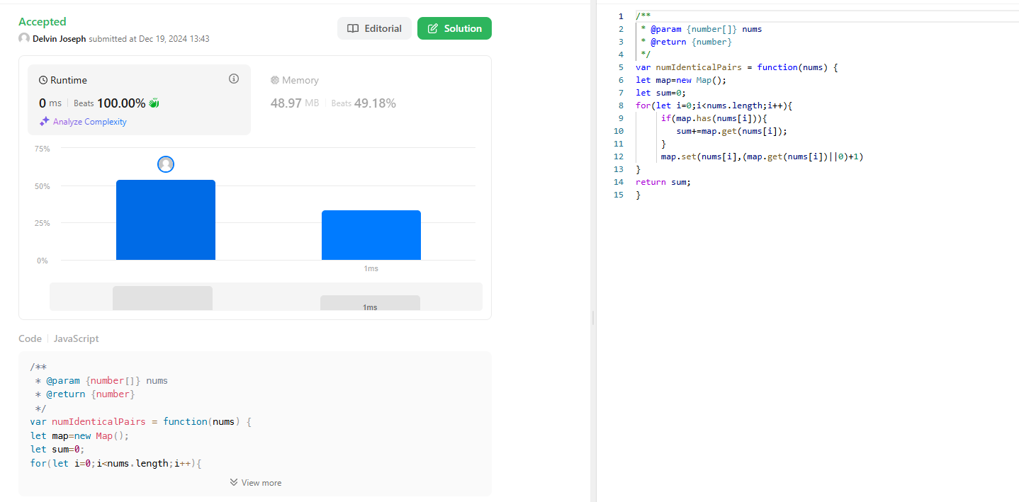Screenshot:

Description:

Time Complexity:O(n)

It iterates all over the n –sized array there for the time complexity is O(n)

Space complexity is O(n) because the code takes extra space for the map Data structure

5)Question: <https://leetcode.com/problems/shuffle-the-array/description/>

Solution: <https://leetcode.com/problems/shuffle-the-array/submissions/1482730307>

Time Complexity: O(n)

Space Complexity: O(n)

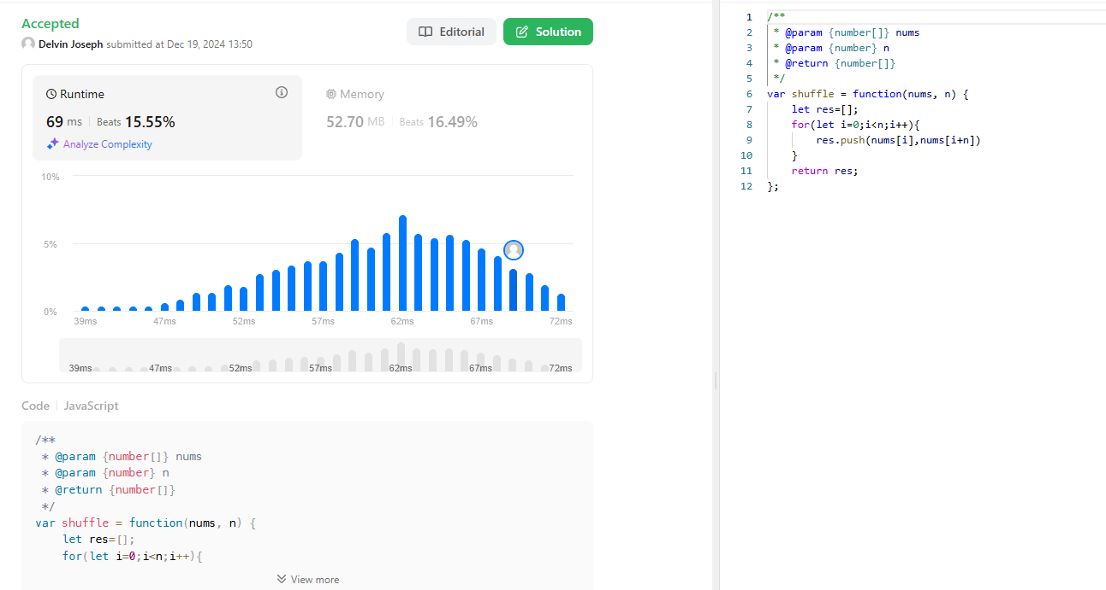Screenshot:

Description:

Time Complexity:O(n)

It iterates all over the n –sized array there for the time complexity is O(n)

Space complexity is O(n) because the code takes extra space for the result array it can get n space with respect to the size of the array